Super senses
Answer the following questions:
1. Define the term super senses with suitable example.
Ans:. Super sense is a term used to describe the ability of some animals to sense things beyond human perception .
For e.g silvertip grizzly bears can smell their enemies located as far as 18 miles away .
2.Observe the picture given below and answer the following questions:
(I) When ants move they leave a smell on the ground. Name the chemical secreted by Ants.
Any by own
(ii) How do insects use pheromones to communicate?
Insects rely on pheromones more than any other method of communication. Pheromones are chemical signals that allow members of the same species to interact.
for example, Ants can scent the pheromones left behind by other ants.


3.How do humans use dogs' super senses?
Detecting Criminals: Dogs can be trained to track criminals and identify them based on scent.
Detecting Explosives: Dogs are used to sniff out explosives in public places, airports, and other locations.
Recovering Stolen Goods: Dogs can be used to locate stolen goods based on smell.

4.While going to a forest John observed that some animals produces some different sounds while seeing some danger what are that sounds called? Why this animals used to produce such sound? Explain your answer with suitable examples.
Any by own
5. Some animals go into a long, deep sleep in certain seasons. Then they are not seen for many months. Where do you think they have gone?
Ans – Long deep sleep of animals during certain seasons especially in winter is called Hibernation.
Hibernation is a deep sleep which helps animals to save their energy and survive in winter without eating much.
6. Tigers are becoming endangered animals in-spite of having sharp senses. Write down the reason behind it.
Ans. Some dangers to tigers in the jungle are
- Hunters and poachers who kills them for their skin.
- Dangers are also from destruction of forests,forest fire and the growing imblance in nature .
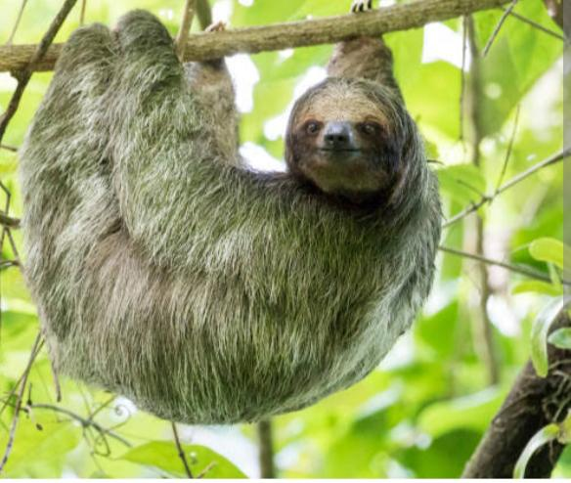
7.Explain why this animal in the above picture hanging upside down. write it’s 3 features.
Ans by own.
8.List the difference between Endangered and Extinct animals.

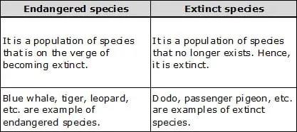
9. What does NTCA stands for? Write any one role of NTCA.
Ans - NATIONAL TIGER CONSERVATION AUTHORITY

The National Tiger conservation Authority (NTCA) is a wildlife conservation agency formed to protect the endangered Bengal tiger in India. It was established by the Government of India in December 2005 for the management of Project Tiger and the various tiger reserves in India.
Note : Project Tiger is a wildlife conservation movement intiated in India to protect the endangered tiger . Launched – April 1973.

